**User Experience Engineering**

**SE3050**

**Lab 6**

|  |  |  |  |
| --- | --- | --- | --- |
| **Group Number** | **2021S2-REG-WE-37** | | |
| **Registration No** | | **Name** | **Contribution** |
| IT19245584 | | M.M.A.D.N.Sandeepa | Prototype v1  Prototype v2  User Feedback |
| IT19243672 | | Praveena.T | Prototype v1  Prototype v2  User Feedback |
| IT19387536 | | J.A.D.S.Crishani | Prototype v1  Prototype v2  User Feedback |
| IT19116952 | | Abarna.U | Prototype v1  Prototype v2  User Feedback |

**Table of content**

Sketches………………………………………………………………………………….3

Wireframes………………………………………………………………………….........9

Prototype (Version 1) …………………………………………………………………...19

Feedback (User Interviews) ………………………………………………………..........24

Prototype (Version 2) …………………………………………………………………....28

* **Sketches**
* **IT19116952**

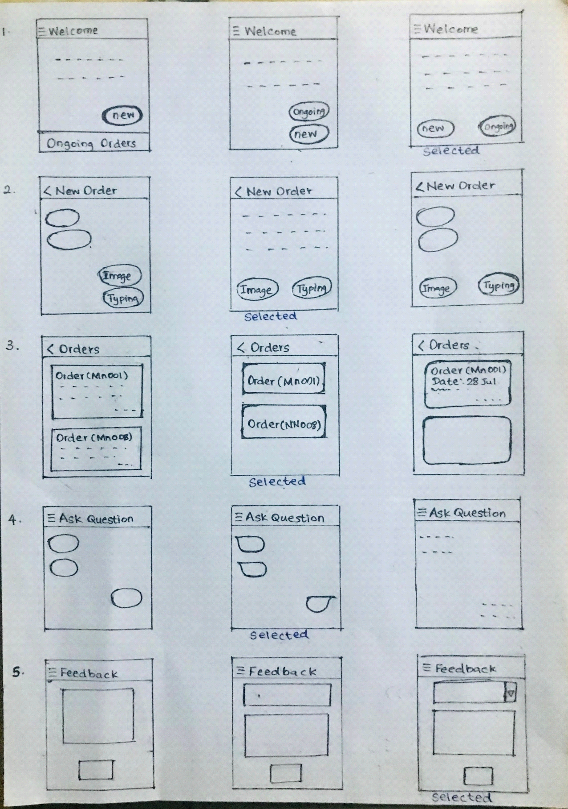

* **IT19245584**

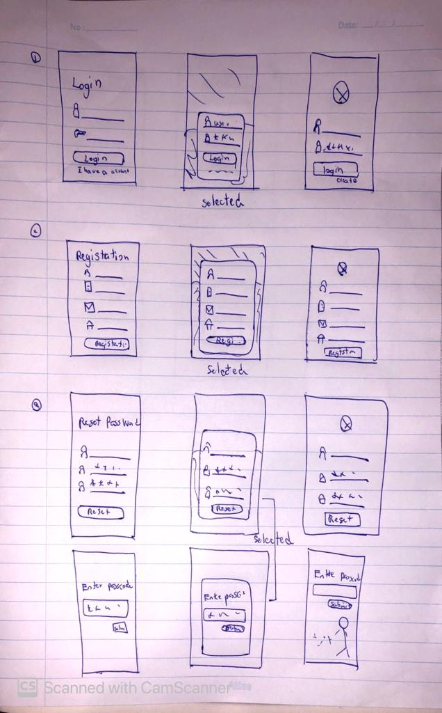

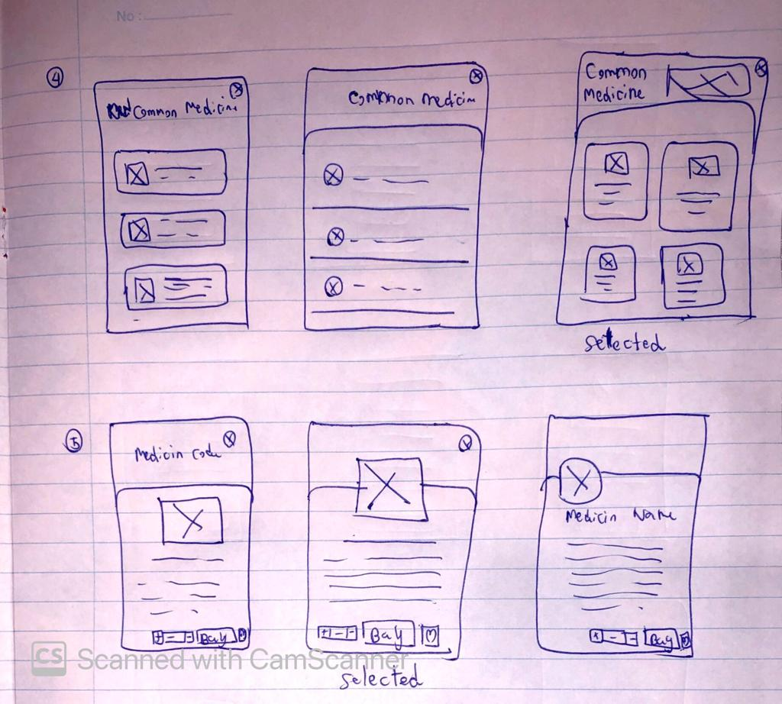

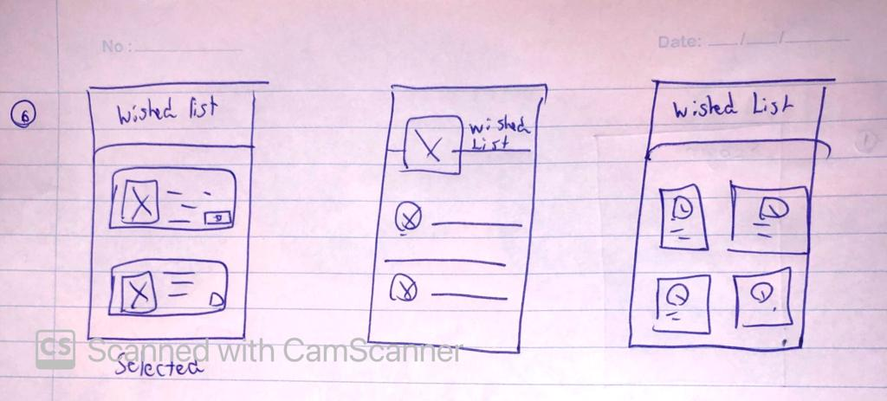

**IT19243672**

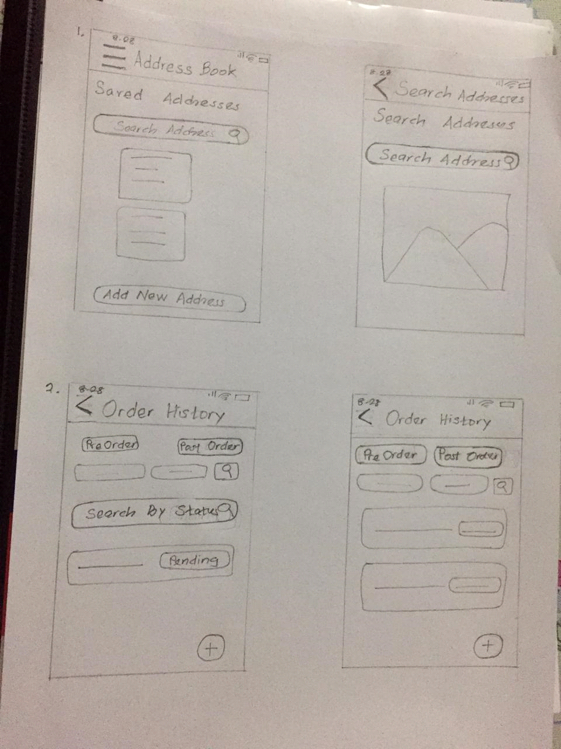

* **IT19387536Diagram

  Description automatically generated with low confidence**

* **Wireframes**
* **IT19116952**

**Rejected**

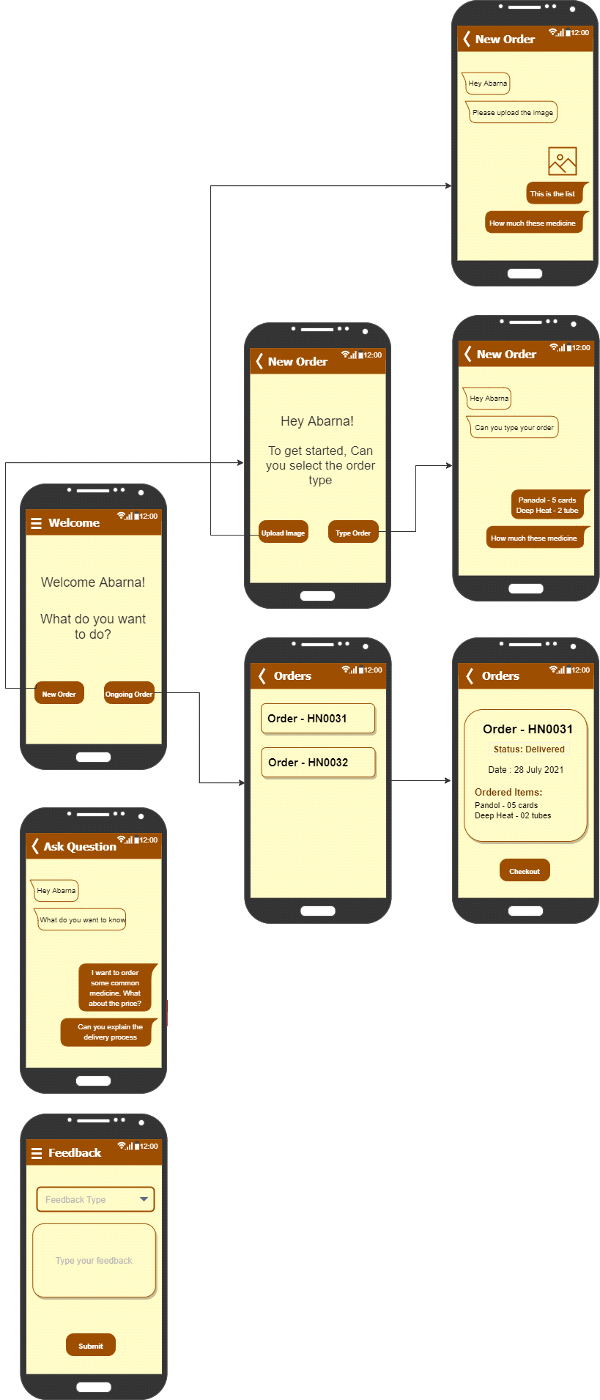

**Accepted**

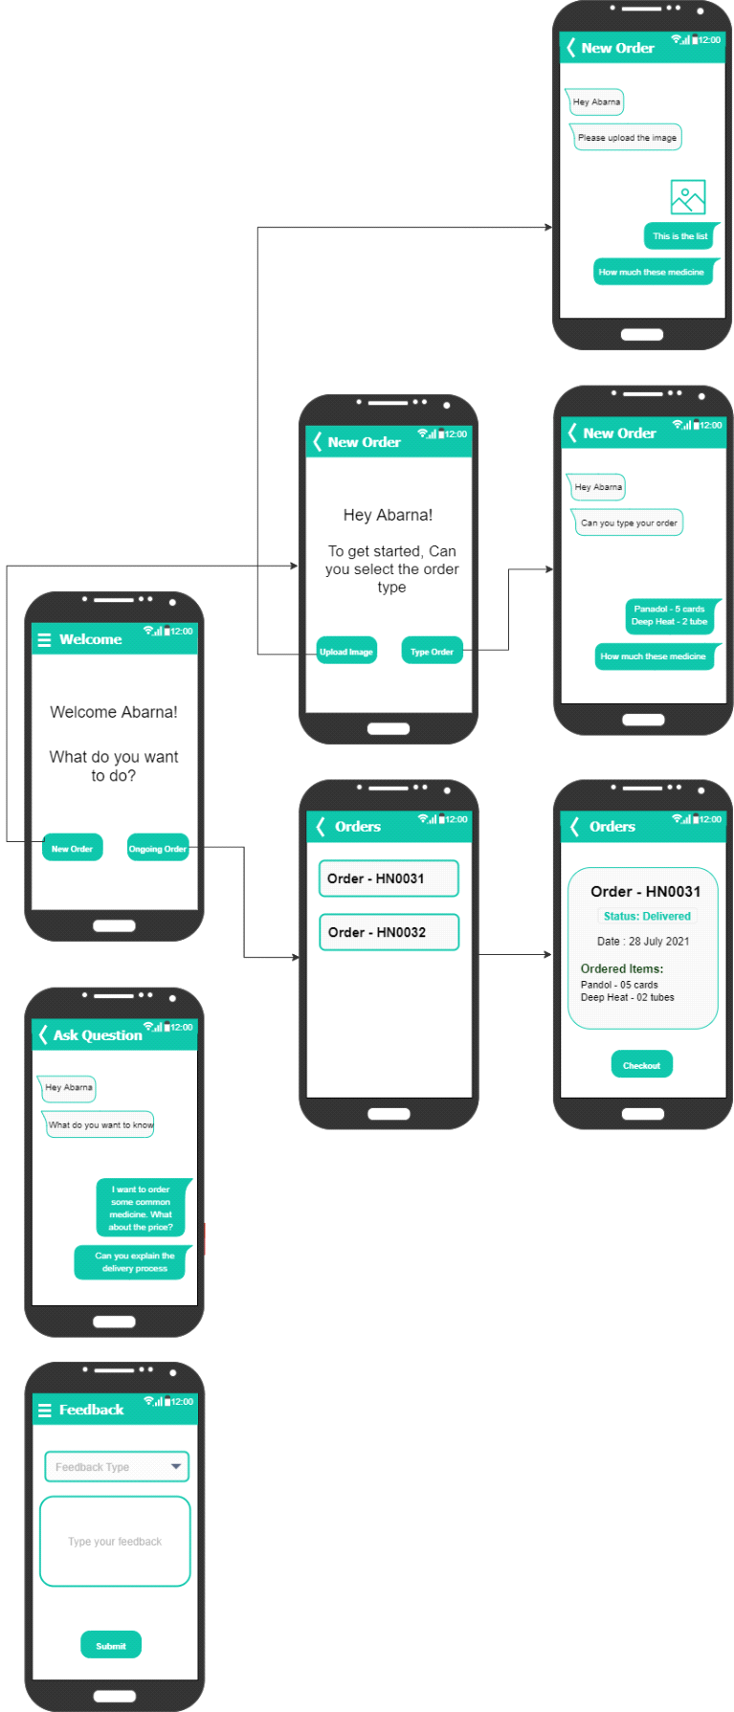

* **IT19245584**

**Rejected**

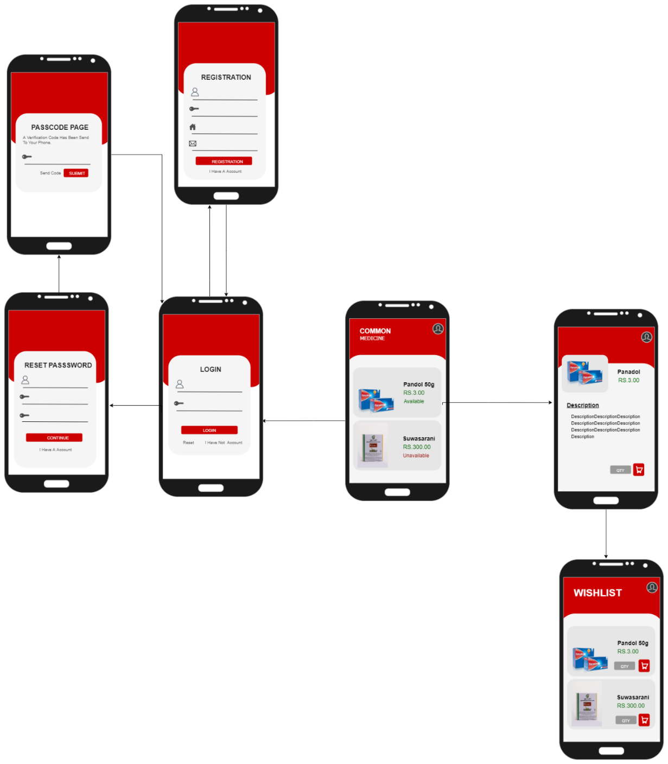

Accepted

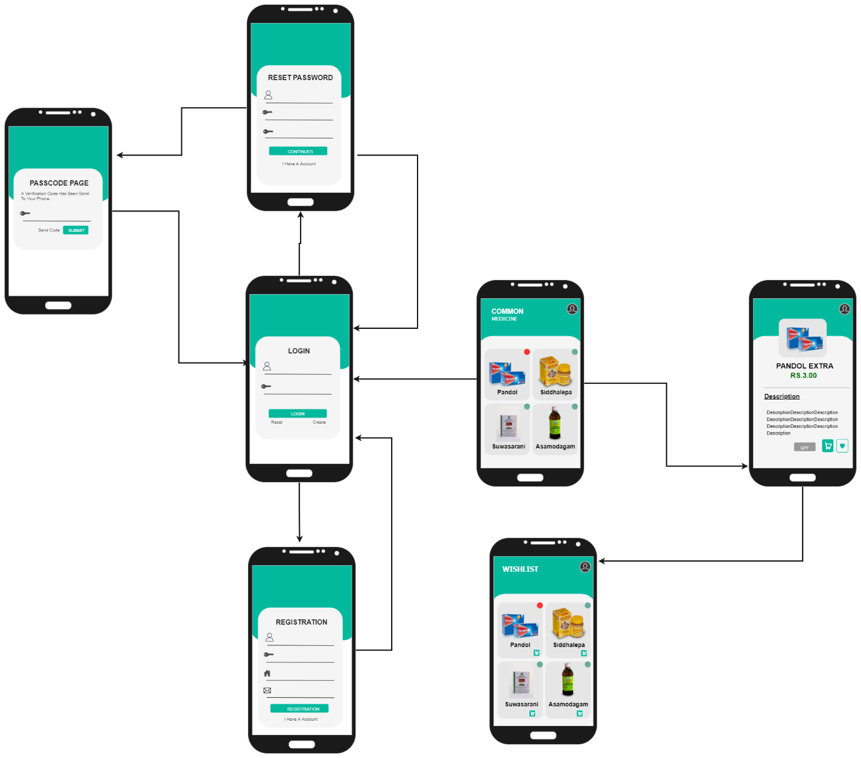

* **IT19243672**

Rejected

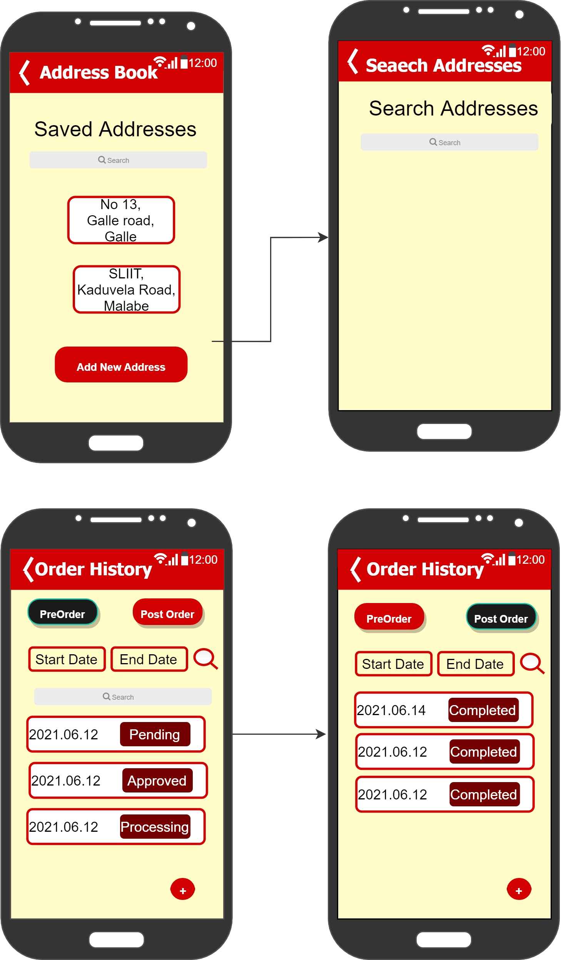

**Accepted**

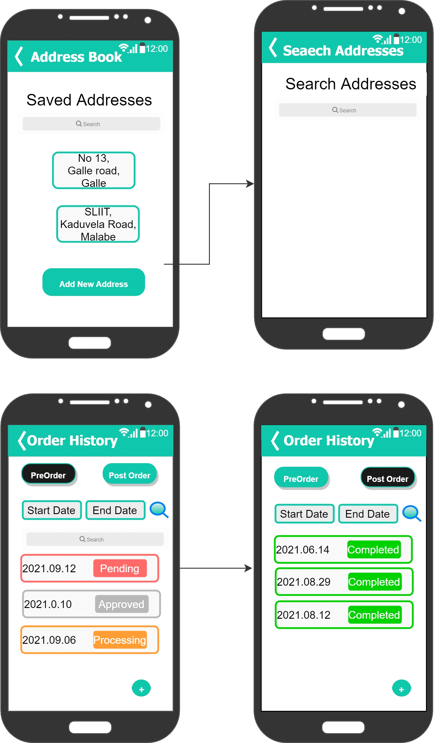

* **IT19387536**

**Rejected**

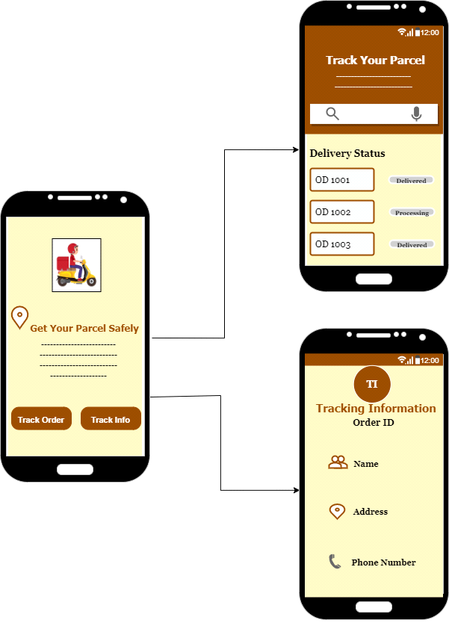

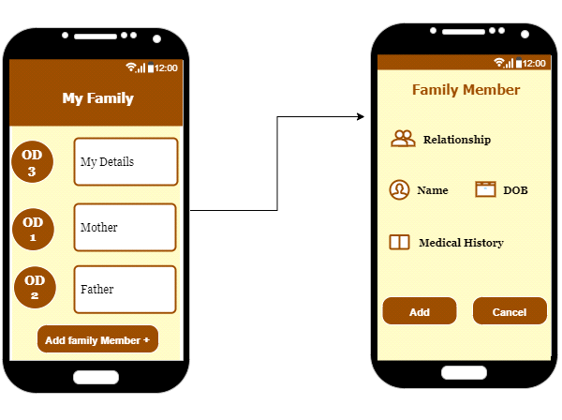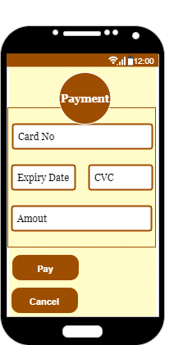

**Accepted**

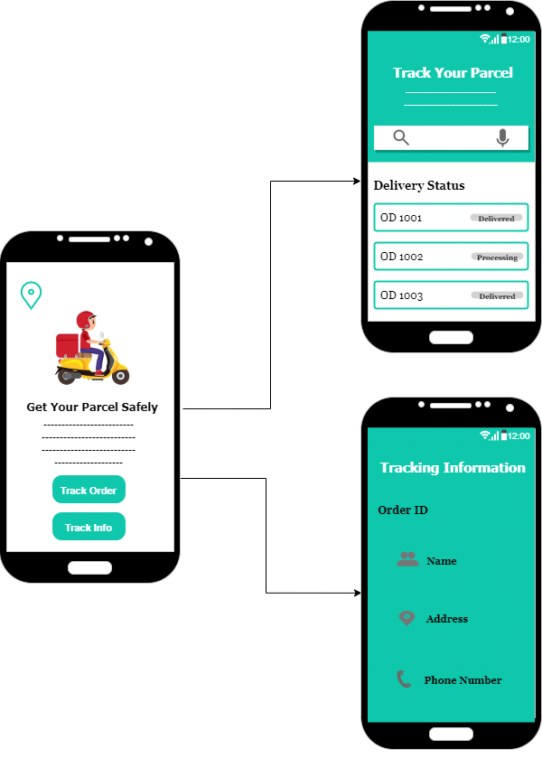

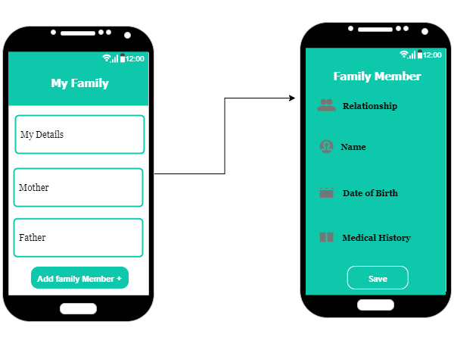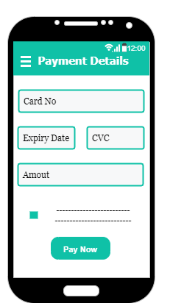

* **Prototype - Version 1**

<https://www.figma.com/proto/DS2XglA1D4n0NKsSMvSIfm/Prototype-V1?page-id=0%3A1&node-id=1%3A248&viewport=241%2C48%2C0.5&scaling=scale-down&starting-point-node-id=1%3A248>

|  |
| --- |
| IT19245584 – |
| IT19243672 – |
| IT19387536 – |
| IT19116952— |

**Interviews (User Feedback)**

[**https://1drv.ms/u/s!AjPE7XS2Gq7yarz8n1HO8vMWIvY?e=4RZXOF**](https://1drv.ms/u/s!AjPE7XS2Gq7yarz8n1HO8vMWIvY?e=4RZXOF)

**Scripts**

* **Patient**

**Interviewer**: Hi happy to see you again

**Patient**: good to see you too

**Interviewer**: Shall we start the interview

**Patient**: Yeah sure

**Interviewer**: what do you think about the colors used in this prototype?

**Patient**: the color selection is good

**Interviewer**: are you able to click all the buttons available in this prototype

**Patient**: yes, all buttons are accessible

**Interviewer**: Are you able to submit the details?

**Patient**: Yes of course.

**Interviewer**: Great, what do you think about the font size?

**Patient**: good. but the font size is little big in some pages

**Interviewer**: does this app work faster

**Patient**: no, the speed is fine

**Interviewer**: Is the login page looks good?

**Patient**: yes, it's great

**Interviewer**: Nice, do you think there is a need to reset password?

**Patient**: I think reset password option is very important. I used to forget my password. So, if there is an option and when it sends a code to mobile number or email address it will be more useful. Personally, I love this option.

**Interviewer**: Cool, are you able to search addresses?

**Patient**: Yeah, I am having the ability to search address from common areas but not small areas, but I am ok with this.

**Interviewer**: Okay, did you save any addresses?

**Patient**: Yes, I could save address using the options provided.

**Interviewer**: is the order status visible?

**Patient**: Yes, it is visible. The color used is favorable to denote each status type. It is very useful and can recognize each status easily.

**Interviewer**: Great, did the notification function work in this prototype?

**Patient**: Yes, it is working as normal mobile applications which we use regularly.

**Interviewer**: what happened when you clicked the new order button?

**Patient**: it navigated the new order page I was able to select the order type by clicking the buttons

**Interviewer**: is the feedback page user friendly?

**Patient**: yes, but it could be modified little bit

**Interviewer**: sure, do you think view order page contain all relevant information

**Patient**: yes, but I was unable to see the price of the medicine

**Interviewer**: are you okay with the interface of the payment?

**Patient**: yes. It’s good. But my only concern is about the payment methods.

**Interviewer**: do you need more payment types?

**Patient**: yes. Can u add the master card transaction?

**Interviewer**: yes, sure. Do you like the additional option where you can save your daily members medical details?

**Patient**: yes, it is very useful to all my family members

**Interviewer**: what do you think about this prototype?

**Patient**: overall it's nice and user friendly. I think if there are some small changes, it’ll be more user friendly.

**Interviewer**: does this prototype fulfill your needs?

**Patient**: yes, this prototype is totally satisfied

**Interviewer**: thank you for participating in this interview we will consider your feedback thank you so much

**Patient**: thank you

* **Pharmacy**

**Interviewer**: Hello, Good evening. We met last time through an interview regarding pharmacy app.

**Pharmacist**: Hello. Yes, I can remember. How is the work going on?

**Interviewer**: We have made the prototype with the suggestions we received. We need your feedback regarding the prototype.

**Pharmacist**: Yes, sure. I will use it and give the feedback.

**Interviewer**: What do you think about the security available in the app?

**Pharmacist**: The app is highly secured with the register, login, password reset options. The color selection for the app is good compared to the previous one.

**Interviewer**: Are the images of medicines clear?

**Pharmacist**: The images are very clear.

**Interviewer**: Are the buttons clickable when using the app?

**Pharmacist**: Yes, I can click the buttons.

**Interviewer**: Can you search for medicines?

**Pharmacist**: Yes, the search functionality is working properly.

**Interviewer**: Can you click all the links to navigate?

**Pharmacist**: Yes, I can navigate through the links easily.

**Interviewer**: What do you think about font size visibility?

**Pharmacist**: Most of the font size are good, but some looks too bigger.

**Interviewer**: Does the app cater to your needs?

**Pharmacist**: Yes. It caters my needs. It fulfils the requirements of the pharmacist.

**Interviewer**: Are you getting notifications at the proper time?

**Pharmacist**: Yes, I am getting on time.

**Interviewer**: Can you change the order status?

**Pharmacist**: Yes, I can change the status. When I change the status, it appears with different colors. It is very useful to identify each status separately.

**Interviewer**: What do you think about the prototype of the delivery home page?

**Pharmacist**: Actually its good. But can u add attractive image for the delivery home page.

**Interviewer**: Are the delivery pages containing all the details that you wanted?

**Pharmacist**: Yes, all the details are there. But can you change the tracking information page design and fonts.

**Interviewer:** Yes, sure. I will change them. Thank you.

**Pharmacist:** You are welcome.

* **Prototype – Version 2**

<https://www.figma.com/proto/NqSgL7ZskzJoCEh8wPNw9d/Prototype-V2?page-id=0%3A1&node-id=1%3A320&viewport=241%2C48%2C0.5&scaling=scale-down&starting-point-node-id=1%3A248&show-proto-sidebar=1>

|  |
| --- |
| IT19245584 – |
| IT19243672 – |
| IT19387536 – |
| IT19116952— |